Subhradip Debnath  
Sec : A  
Roll : 19  
CSE Department  
Institute of Engineering and Management, Kolkata

Date : Tuesday, 1 September 2020

**Assignment-4**

Q1. Write a shell program to add two numbers given by user.

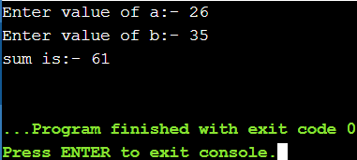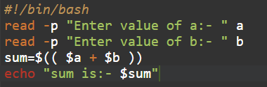

Q2. Write a shell program to perform the swapping between two numbers taken from user during run time.

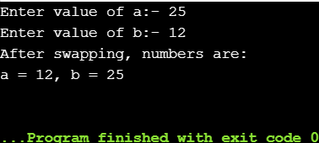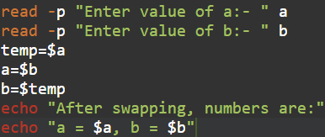

Q3. Write a shell program to perform the multiply two numbers given as command line arguments.

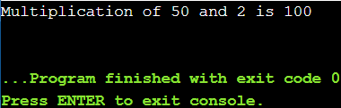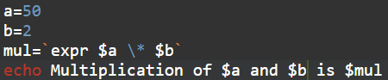

Q4. Write a shell program to print the largest among three numbers by passing the numbers through command line arguments.

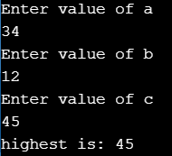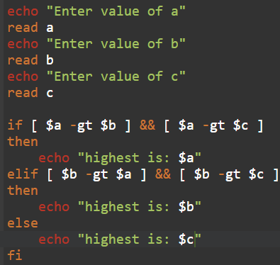

Q5. Write a shell program to display the following mark sheets of students by taking the input marks of student through the terminal

Marks range Grade

90>=M<=100 A

70>=M<=89 B

40>=M<=69 C

M<40 F

